Discovery Report

Volume 7. Visa EMV Acquiring

Orient Commercial Bank

Version 0.1

Status: Draft

Date: 27.10.2020

Prepared by: OpenWay

Author: Tu B. Nguyen

Approved By: Tu B. Nguyen

1. Table of Contents

1. Table of Contents 2

2. History of changes 3

3. Introduction 4

3.1. Notations 4

4. System Overview 6

4.1. Overview 6

5. Visa EMV Acquiring Product Requirement 7

5.1. REQC001. ATM EMV Acquiring 7

5.1.1. Business Requirement 7

5.1.2. Technical Details 9

5.2. REQC002. POS EMV Acquiring 10

5.2.1. Business Requirement 10

5.2.2. Technical Details 10

6. Reconciliation 11

1. History of changes

|  |  |  |  |
| --- | --- | --- | --- |
| version | date | Description | author |
| 0.1 | 27.10.2020 | Initial Version | Tu B. Nguyen |
|  |  |  |  |
|  |  |  |  |
|  |  |  |  |
|  |  |  |  |

**Copyright**

© OpenWay Asia Limited 2020. All rights reserved.

The Copyright of this complete document and every part it belongs to OpenWay Asia Limited. Proprietary material, brand or product names of other parties or trademarks remain with their respective owners. You may not, except with our express written permission, distribute or commercially exploit the content. Nor may you transmit it or store it in any other website or other form of electronic retrieval system. Any sample data used in examples below are completely fictitious unless otherwise noted.

**Disclaimer**

This document and the OpenWay Asia software it describes are furnished by OpenWay Asia Limited under a Software Licensing Agreement, Consultancy Agreement, Variation Request or Confidentiality Agreement, and may be used or copied only in accordance with the terms of such Agreement. Neither this document nor the OpenWay Asia software it describes may be used, sold, transferred, copied, translated, reproduced or transmitted in any form or by any means, electronic or mechanical, for any purpose, in whole or in part, other than in accordance with the terms of such Agreement, or otherwise without prior written consent of OpenWay Asia Limited.

This document describes a generic product or service and should be read in conjunction with other documents relevant to the configuration of any specific system. The licensee of OpenWay software or user of OpenWay Asia services is responsible for ensuring that the product or service described herein meets its own requirements

**Confidentiality**

The information contained in this Document is the property of OpenWay Asia Ltd and contains CONFIDENTIAL information that is produced solely for the benefit of the receiving party named on the front page of this document. The recipient should keep this document and all its information confidential. On no account should this document, in whole or in part, be used, sold, transferred, copied, translated, reproduced or transmitted in any form or by any means, electronic or mechanical, or disclosed or disseminated to any third party, without the express written permission of OpenWay Asia Ltd.

1. Introduction

This document contains the Configuration Details which the WAY4 VISA EMV Acquiring will be configured with in order to meet the Business Requirements of Orient Commercial Bank. It covers the different sections of the WAY4 VISA EMV Acquiring needed to be done in them.

In case a Business Requirements cannot be solved by a system configuration then the same will have to be solved as an Enhancement to the System. Enhancements to the system configuration must be explicitly stated herewith, otherwise configurations described or referenced by this document are assumed to be standard. Enhancements shall not include optional configurations.

* 1. Notations

Notations used in this document are listed in the table below.

***Table 1. Notations***

| Notation | Description |
| --- | --- |
| N | Numeric digits 0 through 9 |
| AN | Alphabetic and Special Characters |
| DT | Date + Format in field description |
| B | Binary representation of data |
| NVAR | Variable length data up to nn characters. There will be two or three character length (depending upon whether maximum data length is 99 or 999) at the beginning of the element to identify the number of positions following to the end of the data element |
| M | Mandatory |
| O | Optional |
| C | Conditional |
| NPA | NAPAS (National Payment Switch) |
| LC | Local Card |
| VCCS | Vietnam Chip Card Specificaiton |
| OCB | Orient Commercial Bank |
| OPW | OpenWay |
| CCD | Common Core Definitions |
| CDA | Combined DDA/Application Cryptogram Generation |
| CB | Certification Body |
| CDOL | Card Risk Management Data Object List |
| DDOL | Dynamic Data Authentication Data Object List |
| DOL | Data Object List |
| IAC | Issuer Action Code |
| IADOL | Issuer Application Data Object List |
| PDOL | Processing Options Data Object List |
| PIN | Personal Identification Number |
| UCOL | Upper Consecutive Offline Limit |
| UN | Unpredictable Number |
| RID | Registered Application Provider Identifier |
| PSN | PAN Sequence Number |
| PK | Public Key of a asymmetric key pair |
| CVM | Cardholder Verification Method |

1. System Overview

## Overview

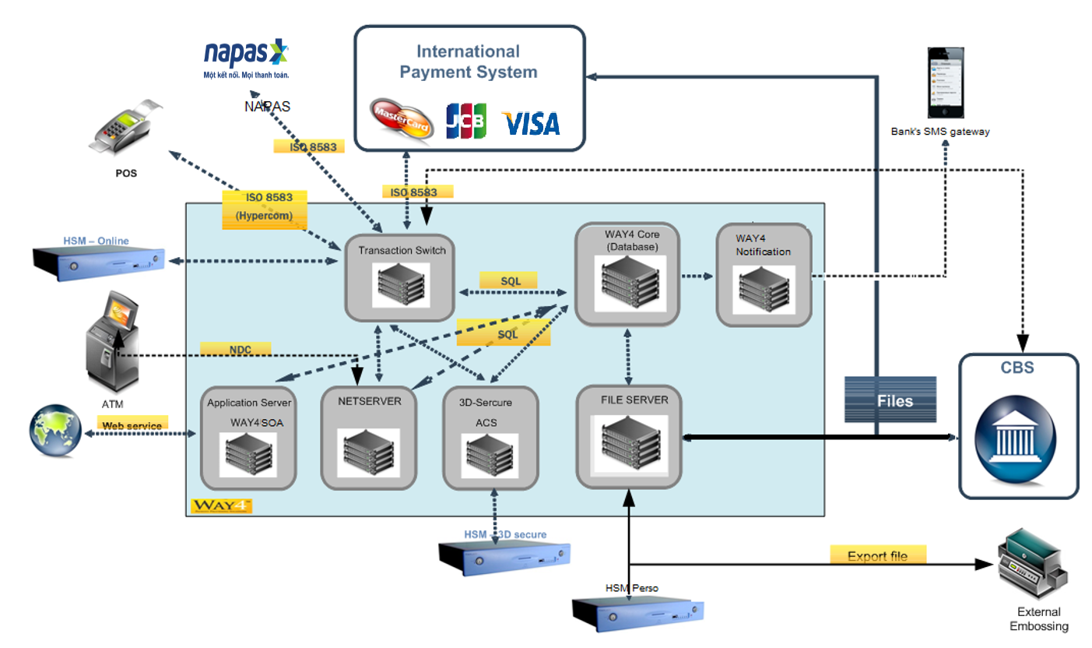WAY4 system was implement on the year 2018. All cardholder and merchant data were migrated

Until now, OCB did implement MasterCard, JCB and Local card to market. In order to provide multi selection to client, OCB want to implement Visa card. Besides, OCB want to acquire all Visa Card on ATM and POS.

1. Visa EMV Acquiring Product Requirement

## REQC001. ATM EMV Acquiring

### Business Requirement



Note: This process (transaction initiation) will not be shown on all of the following transaction flows because this will be repeated once cardholder inserts the card.

**Description:**

1. Cardholder inserts card. If card is ok then next screen will be displayed.
2. Cardholder selects language.
3. ATM tries to do “Begin ICC Initialization” step. If not successful then transaction will be switch to fallback mode.
4. Next ATM do “Complete ICC Initialization” step. If not successful then transaction will be switch to fallback mode.
5. Next ATM do “Begin ICC Application Selection and Initialization” step. If successful then ATM will display all applications which store in CHIP card for Cardholder selection. Otherwise transaction will be switch to fallback mode.
6. Next ATM do “Complete ICC Application Selection and Initialization” step. If not successful then transaction will be switch to fallback mode.
7. Cardholder enters pin. At this screen, Cardholder can use keypad to press CANCEL key to cancel transaction; press CLEAR key to re-enter PIN; press OK key to continue.
8. If On-us card is doing at ATM then:
   * If Way4 verifies PIN successfully then Cardholder will select transaction.
   * If Way4 verifies PIN and get Response code to request first PIN change then next screen will ask cardholder to do change PIN. PIN change flow is written in the following section.
   * If Way4 verifies PIN unsuccessfully then ATM will ask cardholder to re-enter PIN or not?

Otherwise ATM will move to main function for Cardholder select transaction.

**EMV Transaction Support**

For the EMV Chip cards, we support Visa Card’s transaction.

|  |  |  |  |  |  |
| --- | --- | --- | --- | --- | --- |
| No | card type | group | note |  |  |
| 1 | Visa Debit | OCB Card 1 | Bank’s Card |  |  |
| 2 | Visa Prepaid | OCB Card 1 | Bank’s Card |  |  |
| 3 | Visa Credit | OCB Card 2 | Bank’s Card |  |  |
| 4 | Visa Card | Non-OCB Card | Off-us Card |  |  |

Below is transaction list of each card group:

|  |  |  |  |  |  |
| --- | --- | --- | --- | --- | --- |
| No | group | Transaction lists |  |  |  |
| 1 | OCB Card 1 | Cash Withdrawal  Balance inquiry  Mini statement  PIN change  Reversal |  |  |  |
| 2 | OCB Card 2 | Cash Withdrawal  Balance inquiry  Mini statement  PIN change  Reversal |  |  |  |
| 3 | Non-OCB Card | Cash Withdrawal  Balance Inquiry  Reversal |  |  |  |
| 4 |  |  |  |  |  |

**EMV Transaction Flow**

We applied the transaction flow as same as existing flow.

### Technical Details

WAY4 will support the setup and configuration for the ATM Acquiring Product features.

## REQC002. POS EMV Acquiring

### Business Requirement

**Online Transaction Flow**

1. Merchant will select mode to go to Purchase transaction from the menu
2. Merchant will enter the purchase amount and confirm
3. Merchant will insert chip card on OCB POS terminal. Once the card is inserted chip initialization will take place
4. POS will send transaction request to WAY4 switch with ARQC
5. After receiving transaction request, WAY4 switch will identify that card belongs to Visa network. WAY4 switch will route the transaction to Visa for authorization. Visa will forward the transaction to corresponding issuer for authorization
6. Issuer will perform authorization and send response to Visa network with ARPC
7. Visa will forward the response received from issuer to WAY4 switch
8. WAY4 switch will forward the response to POS
9. On receiving the response, card will validate the ARPC
   1. If ARPC validation is successful, POS will display approved response and print the receipt to complete the transaction
   2. If ARPC validation is unsuccessful, transaction will be rejected. In this case if successful response is received, reversal will be generated and sent to Visa.
10. In case of time out between WAY4 switch and Visa, WAY4 switch will send reject response to POS and reversal to Visa network
11. In case of time out with POS, POS will reject the transaction and send reversal to WAY4 switch. WAY4 switch will forward reversal to Visa network.

**EMV Transaction Support**

For the EMV Chip cards, we support Visa Card’s transaction.

### Technical Details

WAY4 will support the setup and configuration for the POS Acquiring Product features.

1. Reconciliation

Apply Visa standard settlement and clearing file.